Banknote Authentication Analysis using K-Means Clustering

The purpose of the Data Science project is to analyse the given data sets Variance and Skewness, variables named V1, V2 from the data_banknote_authentication.csv availed on UCI Machine Learning Repository, to identify the forged and real notes. For analysis, K-Means Clustering with Python is used to depict the two distinct clusters of Real and Forged notes. The aim of the project is to use the given data set to train the model to detect the fake notes. It is an Unsupervised Learning problem which uses Binary Classification method to solve the problem.
The structure of given data set for identifying forged and real notes is show below. V1 represents the Variance and V2 represents the Skewness. Table 2 describe the properties of the given dataset. Figure1 depicts the initial plotting of Variance and Skewness before clustering.

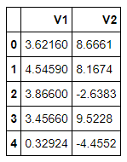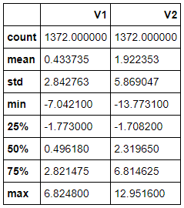
Table 1: Given Dataset Table 2: Properties of dataset
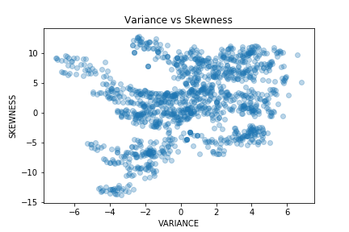
Figure 1: Variance vs Skewness
After plotting the variables V1 and V2, data analysis on graph was done to see whether the data set is suitable for clustering. As the dataset contains a huge amount of data and from the graph it is clear that there is no outliers, made the conclusion that the data is apt for clustering.

The model used is K-Means clustering, the major objective of K-means is to group similar data points together and discover any similar patterns. A cluster can be formed by grouping of similar data points aggregated together considering some specific functionalities and similarities. The ‘means’ in the K-means is obtained by finding the centroid, using average distance calculation.
The following libraries in our project:
• Pandas - used to read and write the csv file
• Numpy - used to perform mathematical operations
• Matplotlib - used to visualize the data in graphs
• sklearn - used for k-means clustering

The two clusters formed by plotting the data before training and after training the model with the data are given below.
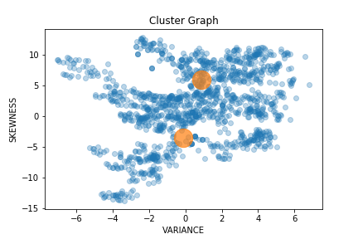
Figure 3: Graph before Prediction

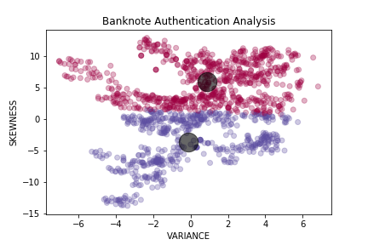
Figure 4: Visualisation using K-Mean Cluster

In Figure 4, the cluster formed after training the model where the lower portion, represented with blue dots represents forged bank notes and the maroon region represents real bank notes which are formed by the clusters at centroids represented by black dots.

